**Project 2: D3 Global Earthquake Visualization**

**Topic**

Our dataset consists of worldwide significant earthquake data from 2150 BC to 2019. Our goal is to plot the data on a D3 Versor visualization, which would consist of a world map with markers that represent earthquakes. We will add layers for earthquake intensity, magnitude, level of destruction, number of casualties, year/month, and other factors.

The goal is to understand the recurrence of earthquakes around the world, and to create recognition of the destructive patterns of earthquakes worldwide. Ultimately, this will contribute to the awareness of the need to prepare for earthquakes.

**Data**

This is the link to our dataset, which we found on Kaggle: <https://www.kaggle.com/mohitkr05/global-significant-earthquake-database-from-2150bc> . The dataset is currently in CSV format. We will store it in a SQLite database.

The dataset consists of over 5,700 earthquakes from 2150 BC to 2019. It contains information on the date and time of occurrence, latitude and longitude, focal depth, magnitude, maximum MMI intensity. It also includes socio-economic data such as the total number of casualties, injuries, houses destroyed, and houses damaged, and damage estimates. It also includes whether the earthquake was associated with a tsunami or volcanic eruption.

**Design**

Our visualization will look like the following design:

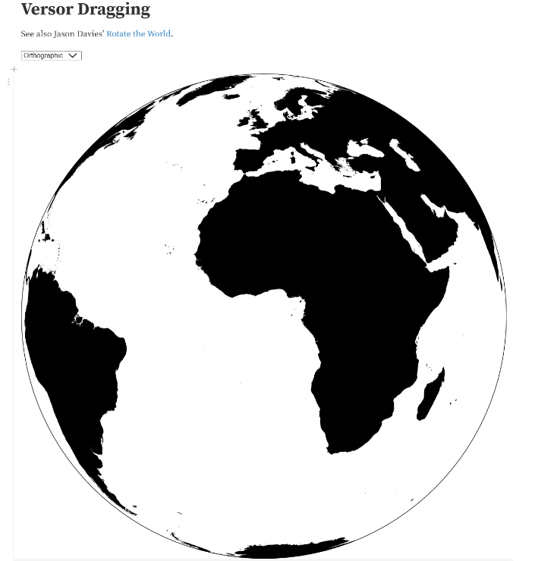

The earthquakes will be represented by markers on the map. The user will be able to interact with the visualization by dragging the cursor to view the other sides of the earth, and by using a dropdown menu to select different layers.

**GitHub Repository**

This is the link to our GitHub repository: <https://github.com/sanjive/Earthquake-Vizualization>